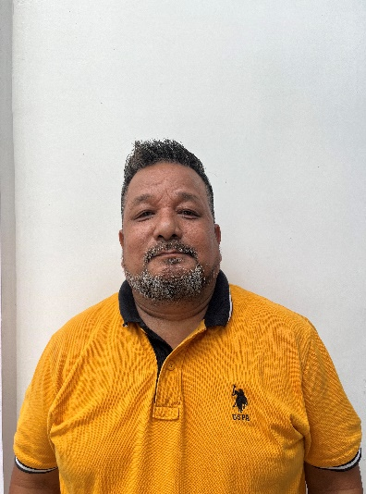
Jaimashi and warm greetings to all respected leaders in the name of our Lord Jesus Christ.
I am thankful for this opportunity to share a brief report of the ministries in West Bengal India. By the grace of God, the mission here continues to grow through various outreach efforts—door-to-door evangelism, street preaching at road junctions, stage programs, and personal interactions with the local community. From the beginning, this has not just been a program but a Spirit-led movement.
One of the most impactful initiatives recently carried out was the Tailoring Camp organized from 5th March 2025 to 28th May 2025 in Totopara, with the support of Love the Lost. This three-month camp proved to be a powerful tool for both social and spiritual engagement. Although most of the participating students came from non-believing backgrounds, the environment created was welcoming and deeply transformational.
Each morning of the camp began with a devotion session. Pastors and leaders were invited to share the Gospel and teach from the Word of God. These devotions were very effective in helping the students understand more about Jesus Christ, His love, and His purpose for their lives. It was encouraging to see their hearts open to the truth day by day.
At the conclusion of the camp, we held a graduation ceremony where the students' parents and guardians were invited. This occasion gave us a wonderful opportunity to preach the Gospel to them as well. Many heard the Good News for the first time and responded with great interest and respect.
Through this journey, we learned and experienced that understanding the needs and necessities of the people, and connecting with them socially, makes the ministry much more impactful and powerful. It opened doors that traditional outreach methods alone could not. Building relationships through practical care and genuine concern helped us earn trust and plant seeds of the Gospel more effectively.
We truly thank God that connecting with unbelievers socially and sharing the Gospel together has proven to be very effective. Following the graduation program, Pastor Dan lama has been regularly visiting and fellowshipping with the families of non-believing students in Totopara.
In addition, from our side in Birpara, we have also followed up with the family of our student Reshma Darjee, and we are seeing positive responses.
After the rainy season, we plan to continue with follow-up visits and deepen our connection with all the students and their families. We believe this ongoing relationship will bring lasting fruit for the Kingdom of God.
All glory and honor to our Lord for His faithfulness. Thank you all once again for your continuous prayers, support, and encouragement.
Bidhan Bal Lama
Birpara, India

